# Basic skills for working with lists.

1. Given the following lists, what values will be returned by the corresponding index values?

temps = [5.6, 10, 0, 100.0, 21, 34]

items = [“car”, “truck”, “quad”, “motorcycle”]

movie = [“Spiderman”, 2022, 23.95]

|  |  |  |  |  |
| --- | --- | --- | --- | --- |
| Index value | Result |  | Index value | Result |
| temps[0] | 5.6 |  | movie[-1] | 23.95 |
| items[2] | quad |  | movie[2] | 23.95 |
| movie[3] | Out of range |  | item[-2] | quad |
| temp[-2] | 21 |  | item[2] | quad |

1. If you wanted to replace the “quad” in the item list with “bike”, what command would you use?

|  |
| --- |
| x = items.index("quad")  items[x] = "bike" |

1. What code would you use to create a list called **reps** containing the value 10, 4 times?   
   ie: reps[10, 10, 10, 10]

|  |
| --- |
| reps = [10] * 4 |

1. You can also create **nested lists**. This is where you insert a list into another list. The list:  
     
   L = [‘a’, ‘b’, [‘cc’,’dd’, [‘eee’, ‘fff’]], ‘g’,’h’]  
     
   has the following structure:  
   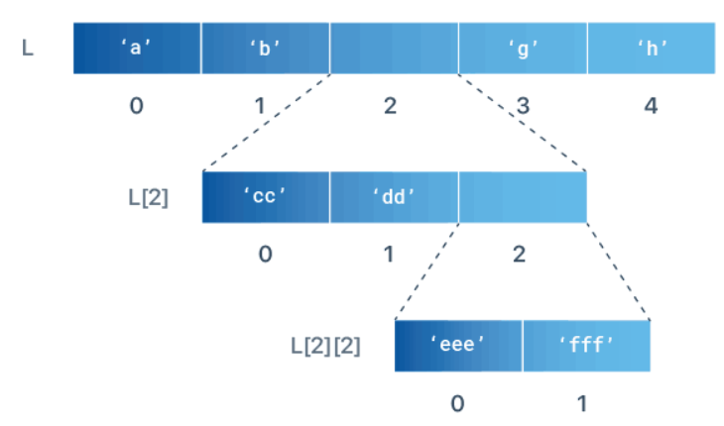  
   Open IDLE, create a new file and call it **nested_lists**.py Add the following code:  
   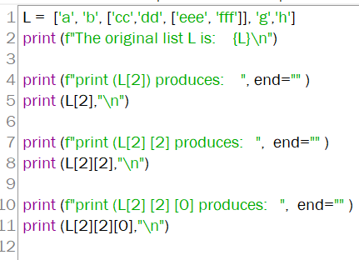
2. **Run the code**.
3. What does print (L[2]) display?

|  |
| --- |
| ['cc', 'dd', ['eee', 'fff']] |

1. What does print (L[2][2]) display?

|  |
| --- |
| ['eee', 'fff'] |

1. What does print (L[2][2][0]) display?

|  |
| --- |
| eee |

You can also use negative indexes to count backward from the end of the list. So, L[-1] refers to the last item, L[-2] refers to the second last item etc.